NAME - HARSH SRIVASTAVA

UID - 19BCS3800

BRANCH – CSE -BD1

AIM = To **design a system for washing machines such that whenever it is filled, a Red LED turns on and if it is empty, a Green LED blinks once every 20 ms.**

CIRCUIT DIAGRAM=

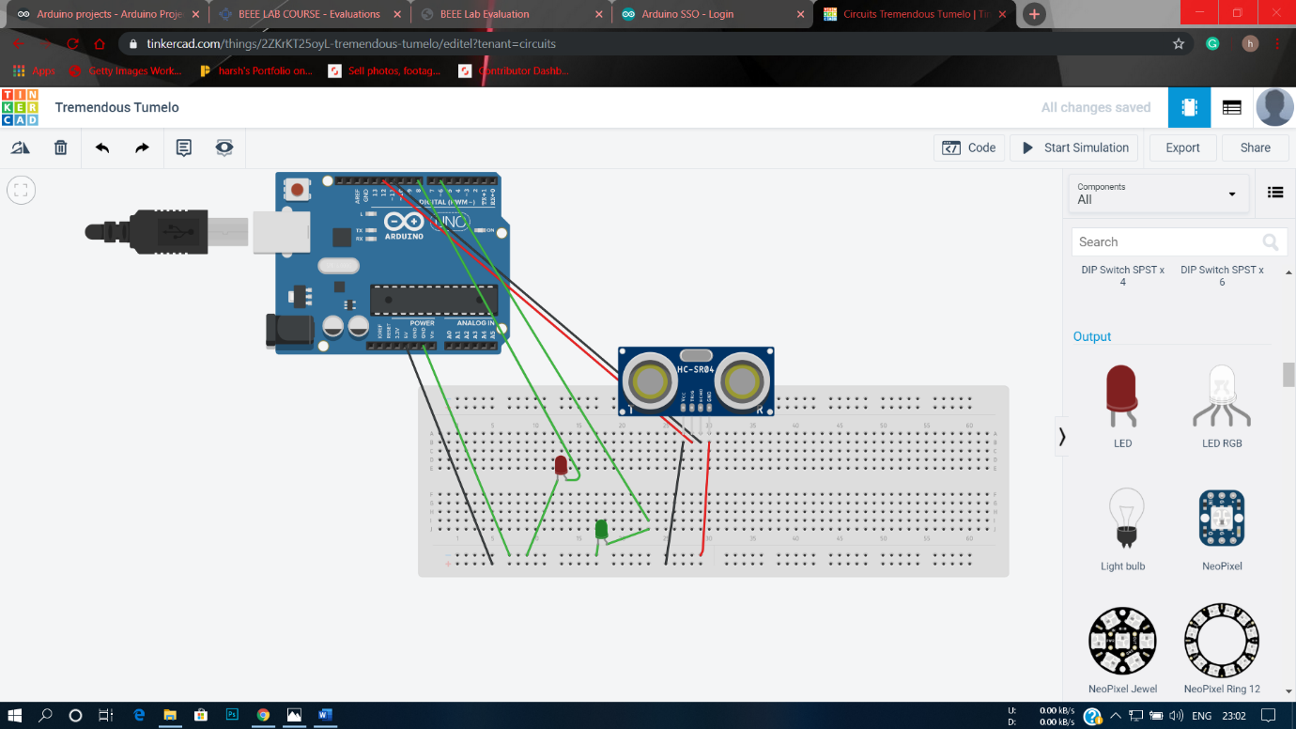

THEORY = We use ultra sonic distance sensor to sence the level of water in washing machine. While there is no water in washing machine ,we run a loop in circuit of green LED which makes it blink with a delay of 20 millisecond. As the water level rise above 0 ,the distance sensor sense the increase in level and terminates the loop which makes the green LED turn off. As the water level rises above the set level limit and stops increasing ,the distance sensor sences that the washing machine is fully filled and another LED [ red LED] starts glowing without any delay ,displaying that its completely fulled .

PROBLEM AND TROUBLESHOOTING=

1. Circuit not connected in right way
2. LED is fused
3. Components not working
4. Not coded correctly or according to hardware

PRECAUTIONS=

1. Not to touch open wire when connected to circuit
2. Not touch Arduino when connected to pc
3. Not to submerge Arduino in water